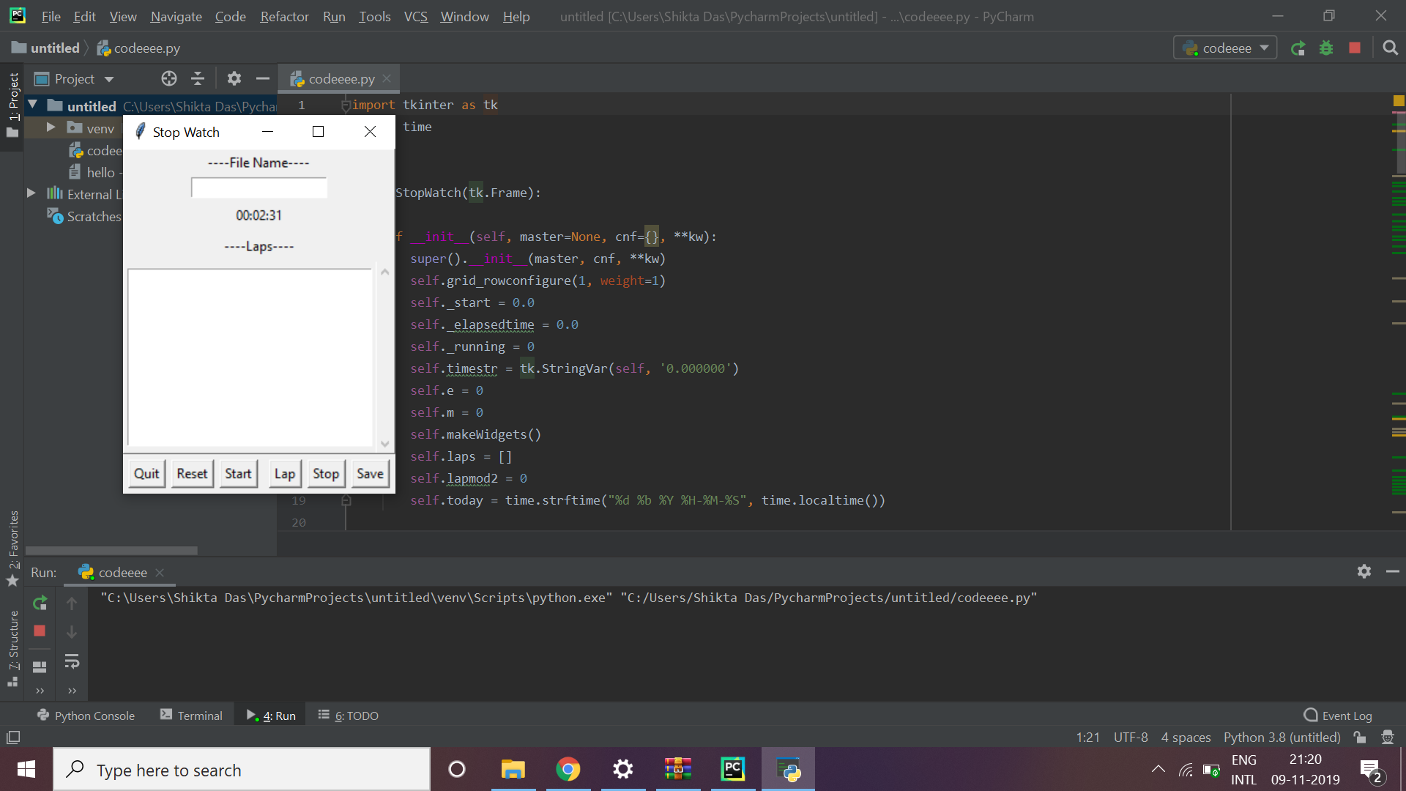

Explanation of code:

A stopwatch is a handheld timepiece designed to measure the amount of time elapsed from a particular time when it is activated to the time when the piece is deactivated. A large digital version of a stopwatch designed for viewing at a distance, as in a sports stadium, is called a stopclock. In manual timing, the clock is started and stopped by a person pressing a button. In fully automatic time, both starting and stopping are triggered automatically, by sensors.

Used Tkinter which is the standard GUI library for Python.

Code starts with importing the required libraries

“import tkinter”

           We make a if loop to manage the intial delay.

         we give 2 arguments .

           first argument given in milliseconds and then calls the function given as second argument.

    Then we triggering the start of the counter.

Start ,reset,save,stop function of the stopwatch is initiated.

If rest is pressed after pressing stop stopwatch shows disable

       Lastly we do  Fixing of the window size.